Chapter
JIT, Lean Operations, and the Toyota Production System

Discussion Questions
1. JIT is a philosophy of continuous and forced problem solving. It is a continuous program that replaces a series of “fad” programs.
2. A lean producer is a company that adopts a philosophy of minimizing waste, striving for perfection through continuous learning, creativity, and teamwork.
3. The Toyota Production System (TPS) has three core components: continuous improvement, respect for people, and standard work practices. TPS is the standard for repetitive manufacturing.
4. Level schedules process frequent small batches rather than a few large batches; the small batches are always changing. They match one day’s demand to one day’s work.
5. JIT allows for safety stock and in-transit inventory (but no more than necessary). Where external, unpredictable issues such as weather arise, more safety stock is necessary. Consignment inventory is also useful. Beyond that, JIT is at risk for events such as weather and work stoppages.
6. Quality relates to JIT: JIT cuts the cost of obtaining good quality; JIT improves quality; and better quality means fewer buffers and therefore a better, easier-to-use JIT system.
7. TPS contributes to competitive advantage through: suppliers, layout, inventory, scheduling, preventive maintenance, quality production, employee empowerment, commitment of management and employees.
8. JIT partnering with suppliers; few suppliers; nearby suppliers; repeat business with the same suppliers; analysis to enable desirable
suppliers to become/stay price competitive; competitive bidding mostly limited to new purchases; buyer resists vertical integration and subsequent wipeout of supplier business; and suppliers are encouraged to extend JIT buying to their suppliers.
9. The word is kanban, and is closely associated with JIT. It relies on visual or other simple signals to indicate when items need to be “pulled.” It is symbolic of the waste reduction, distance reduction, and small lot size that characterize JIT.
10. Standardized, reusable containers within the plant: in shipping; protect the specific quantities to be moved; reduce weight and
disposal costs; generate less wasted space in trailers; and require less labor to pack, unpack, and prepare items. Inside the plant: to convey the quality of the kanban and to protect the items.
11. Lean production is applicable everywhere. It ranges from lean layouts at McDonald’s kitchens (see the Global Company Profile in Chapter 9) to driving down inventory at Arnold Palmer Hospital (see the video case study in this chapter).
12. Virtually all lean techniques have application in both
manufacturing and services. The lean techniques of JIT, layout (work cells), inventory reduction, and tight scheduling have few boundaries.
Ethical Dilemma
What are the ethical issues? Students may disagree, but there may not be an ethical issue for Mega-Mart. There may be an issue of being nice to a good supplier, but that is not necessarily an ethical issue. Mega-Mart is interested in an efficient (and consistently administered) supplier network that drives down costs for its customers. That is a strong ethical argument in itself. (See the work of Michael Porter and his five forces model—firms compete not only via rivalry with direct competitors but also with new entrants, substitute products/services, buyers, and sellers.)
As the seller, what do you do? If the purchased product is special and unique enough, Mega-Mart may be more flexible concerning the RFID implementation schedule. Mega-Mart may also be willing to help with expertise or recommendation of good economical RFID vendors. In a free competitive world, your association with Mega-Mart is a voluntary association between buyer and seller and you can, of course, walk away. Other alternatives include:
- Increasing your sales volume to cover more of your fixed cost
- Doing all of the things that a good operations manager does to become more efficient.
End-of-Chapter Problems
16.1 Demand during lead time-of 2: (1,000 × 2) = 2,000
Safety stock (1/2 day) 500
Maximum inventory level 2,500
Number of kanbans needed:
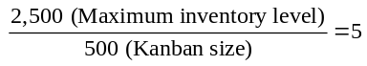
16.2 Demand during lead time 125
Safety stock 62.5
Maximum inventory level 187.5
Number of kanbans needed:
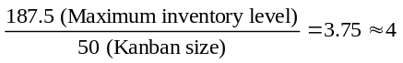
16.3 First, we determine the kanban size. To do this, we determine the production order quantity (see discussion in Chapter 12), which determines our kanban size.
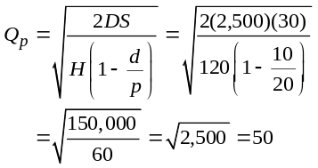
Then we determine the number of kanbans:
Demand during lead time | = 160 (= 16 Days × Daily usage of 10)
Safety stock | = 80 (= 4 × daily production of 20)
Therefore maximum inventory should be | = 240 subassemblies
Because the kanban size is 50 subassemblies, 5 kanbans are appropriate (240/50), rounded from 4.8.
16.4 First, we must determine the kanban size. To do this, we determine the production order quantity (see discussion in
Chapter 12), which determines our kanban size.
16.5 D = 2,000; H = $12; S = $30
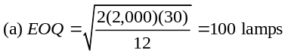
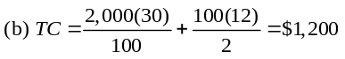
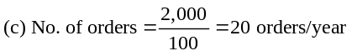
16.6 D = 2,000; H = $20; S = $0.50
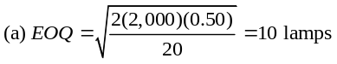
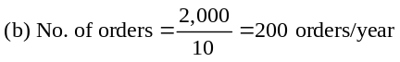
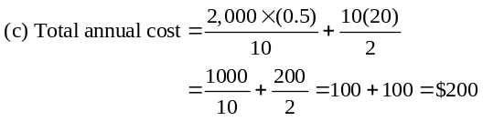
16.7 With JIT, purchase/delivery of goods immediately precedes demand. The decrease in EOQ for lamps, from 100 to 10, increases deliveries from 20 to 200. With the new relationship with Specialty Lighting, Discount-Mart has reduced its inventory costs, a usual pattern for companies using JIT purchasing.

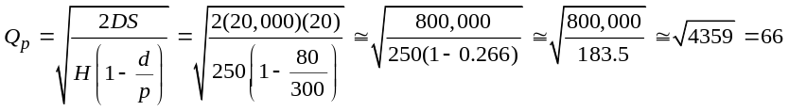
Then we determine the number of kanbans:
Demand during lead time = 240 (= 3 days × Daily usage of 80)
Safety stock = 150 (= 1/2 × daily production of 300)
Therefore maximum inventory should be = 390 mainshafts.
Because the kanban size is 66 mainshafts, 5.9 kanbans are
appropriate (390/66). This can be rounded to 6.
16.8 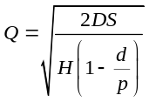
where D = annual demand, S = setup or order cost,
H = holding cost, d = demand rate, p = production rate. Solving for S (setup cost):
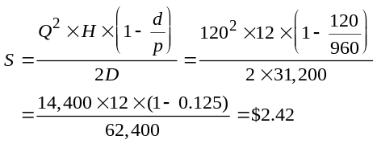
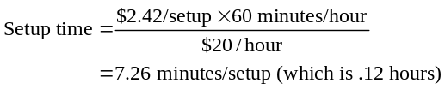
16.9 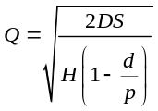
where D = annual demand, S = setup or order cost,
H = holding cost, d = daily demand rate, p = daily production rate. Solving for S (setup cost):
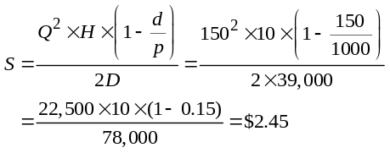
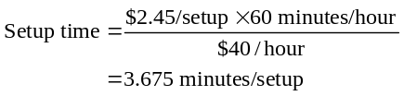
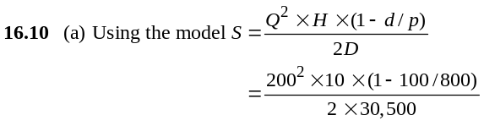
S = $5.74
(b) 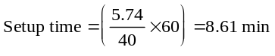
Additional Homework Problems
Here are solutions to the additional homework problems at
www.pearsonglobaleditions.com/myomlab.
16.11 Demand during lead time (1 day) 1,500
Safety stock (1/2 day) → 750
Maximum inventory level 2,250
Number of kanbans needed:
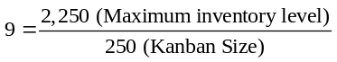
16.12 First, we determine the kanban size. To do this, we determine the Production Order Quantity (see discussion in Chapter 12), which determines our kanban size.
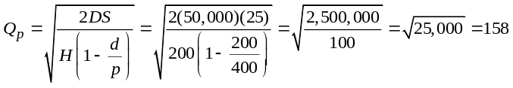
Then we determine the number of kanbans.
Demand during lead time | = 1,200 (= 6 days × daily usage of 200)
Safety stock | = 400 (= 1 times daily production of 400)
Therefore maximum inventory should be | = 1600 compressors.
Because the kanban size is 158 compressors, 10 kanbans are appropriate (1600/158).

Case Studies
MUTUAL INSURANCE COMPANY OF IOWA
1
1. We can assume that if carried out properly, all the good things
that are supposed to happen with JIT will. For instance, we expect reduced floor space, higher quality (fewer errors), less WIP, empowered employees with higher morale, faster throughput, etc.

2. Suggested layout follows:
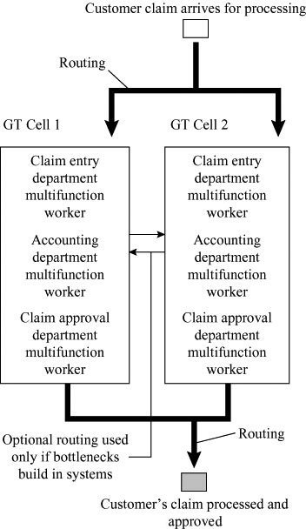

3. We are assuming that the personnel can be cross-trained for all the jobs in the cell, that training budgets will increase, and that equipment utilization will improve, yielding less capital expenditure.
4. The new JIT system will reduce throughput time, yield satisfied customers, and create more satisfying jobs. (Sounds like Deming.)
2
JIT AFTER A CATASTROPHE

This case and the discussion below (much of which is from a
series of Wall Street Journal articles; May 19, 2008, B1, B2; July 20, 2007, B1; September 13, 2001, B1, B4; and May 8, 1997, A1, A5) can make for a very interesting class discussion. More
resourceful students may even go to the sources and be prepared with these answers.

1. What do you do to keep coupling production going?

At Caterpillar:
 The morning after the tornado Mr. Folley was on site with Steve Brister, whose company had built the facility 10 years earlier.
 Folley gave Brister a two-week deadline to get the plant running.
 Within 48 hours Caterpillar engineers were scouring the world for couplings.
 Caterpillar recruited new vendors and dispatched manufacturing engineers to check quality and capacity.
 The company promised Oxford employees that their paychecks would continue.
 It recruited volunteers to move temporarily to a Michigan plant where some coupling production was started.
 Caterpillar built a new temporary supply chain that pieced together the capability of many plants.

At Toyota:

The support that parts makers provided Toyota during its crisis helps indicate why Japan’s auto companies return the
loyalty—often to the detriment of U.S. and other foreign parts makers. Toyota and Aisin didn’t bother to approach any foreign companies during the crisis, a Toyota spokesman says, because “there were no foreign suppliers in a position to help us.”
Suppliers never asked Toyota or Aisin what they would be paid for rushing out the valves, says Somic’s Mr. Ishikawa in a 2001 Wall Street Journal article. “We trusted them.”
Indeed, as the first valves arrived at Toyota factories, Aisin told the suppliers it would pay for everything, from drills and overtime pay to lost revenue and depreciation. And Toyota promised the suppliers a bonus totaling about $100 million “as a token of our appreciation,” says Mr. Okuda, its president. He adds that the auto maker will certainly remember the companies that pitched in during its crisis.

2. JIT has survived because of the classic advantages of JIT: reduced inventory with its entire cost savings and fewer write-offs; a requirement for high quality; and motivation for an element of standardization.

3. The consistent response of Caterpillar, Toyota, Chrysler, etc. is to continue with JIT. JIT works, and it works in spite of a catastrophe. The efficiencies are just too overwhelming. The systems, as noted below, may get fine-tuned and back-up plans may be improved, but JIT is a winner

4. Policy changes:
 At Caterpillar management is considering adding some machines at factories that can duplicate some of the couplings. The company is also reviewing operations world-wide to determine how to cost-effectively reduce risk at key points. And is considering building another coupling plant outside the U.S. to supply future growth and provide “back-up” if there is another crisis.
 at Toyota: The fire and its aftermath have left Toyota executives convinced that they have the right balance of efficiency and risk. “Many people say you might need to scatter production to different suppliers and plants, but then you have to think of the costs” of setting up expensive milling machines at each site, Mr. Ikebuchi is quoted in the WSJ as saying. “We relearned that our system works.”
In fact, the fire may have made the system even more efficient. Nisshin Kogyo Co., which was making the other 1% of Toyota’s P-valves, says that during the crisis it raised production efficiency 30% by speeding up production.
The fire spurred Toyota to begin an effort to trim the number of its part variations, a project that should eventually cut costs. And sole-source suppliers are moving quickly to build failsafe supply chains. In some cases this means revamping systems to facilitate easily shifting to another site if disaster strikes.

Video Case Study
JIT AT ARNOLD PALMER HOSPITAL
A 9-minute video, filmed specifically for this text, is available from Pearson Education and is designed to supplement the written case.
1. What do you recommend be done when an error is found in a pack as it is opened for an operation?
The immediate solution is get another pack. (Although APH uses a JIT system, there are some spares—actually almost a one-day buffer.) However, the advantage of JIT is that the error is known immediately—at APH within a day of delivery. McKesson can track back thru the system and identify the cause of the error—and take corrective action!
2. How might the procedure for custom surgical packs described here be improved?
APH could reduce the number of packs in the buffer from one day to less than one day fix leading.
3. When discussing JIT in services, the text notes that suppliers, layout, inventory, and scheduling are all used. Provide an example of each of these at APH:
- Suppliers get on board with high quality frequent deliveries.
- Layout is modified to be near (perhaps adjacent) to the work area and with no space for excess storage.
- Inventory is at a minimum to ensure that bad product is not made, shipped, and stored. Minimum inventory allows immediate feedback on quality. The plus at APH is that quality (i.e., sterile packs) is enhanced by maintaining only limited storage.
- Scheduling that meets JIT demands, schedules only what is needed when it is needed.
4. When a doctor proposes a new surgical procedure, how do you recommend the SKU for a new custom pack be entered into the hospital’s supply chain system?
The request for changes and all new products goes to the Medical Economics Outcomes Committee. Reducing the proliferation of SKUs is a continuing issue at APH, as it is for operations personnel everywhere.

